LeetCode Program 2235

Link :- https://leetcode.com/problems/add-two-integers/

Successful Submission
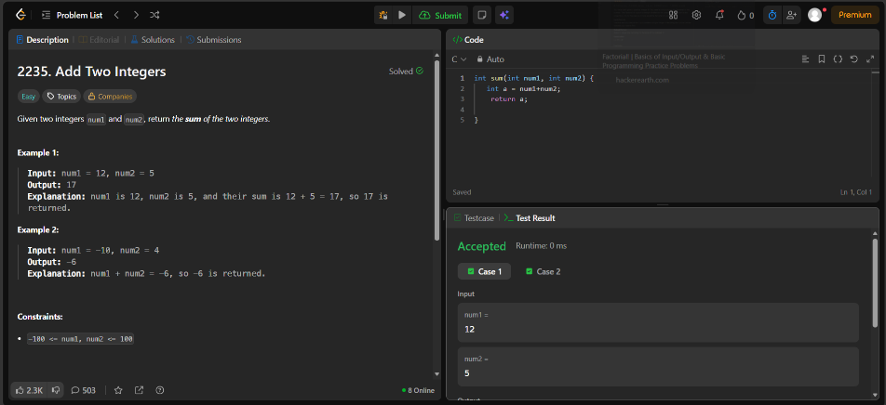

Source Code


